Vincent Schiraldi

Vincent Schiraldi is an Adjunct Professor at the Columbia School of Social Work and Senior Fellow at the Columbia Justice Lab. He has extensive experience in public life, founding the policy think tank, the Justice Policy Institute, then moving to government as director of the juvenile corrections in Washington DC, as Commissioner of the New York City Department of Probation and Correction, and Senior Policy Adviser to the NYC Mayor's Office of Criminal Justice. Schiraldi gained a national reputation as a fearless reformer who emphasized the humane and decent treatment of the men, women, and children under his correctional supervision. He pioneered efforts at community-based alternatives to incarceration in NYC and Washington DC. Schiraldi received an MSW from New York University, and a Bachelor of Arts from Binghamton University.

Sara Norman
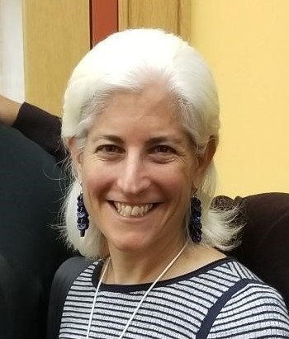

Sara Norman is the managing attorney of the Prison Law Office, a nonprofit that advocates for the rights of youth and adults behind bars in California and Arizona. She is counsel for the plaintiff class in Clark v. California, a class action on behalf of thousands of people in California prisons with intellectual disabilities; in Gray v. County of Riverside, a class action lawsuit to improve health care in one of the largest county jail systems in the U.S.; and in Farrell v. Cate, a taxpayer lawsuit that forced sweeping reforms in California's juvenile justice system. Ms. Norman was a member of the litigation team in Brown v. Plata, in which the U.S. Supreme Court confirmed a lower court order requiring California to significantly reduce its severe prison overcrowding, an accomplishment for which the team was selected as a finalist for the 2010 Trial Lawyer of the Year Award from the Public Justice Foundation. She is the recipient of numerous awards, and one of the top women litigators in California named by the San Francisco and Los Angeles Daily Journals. She graduated from Harvard College and Yale Law School, and clerked for Judge Robert Carter in the Southern District of New York.
Panel One:

Moderator:

Liz Glazer
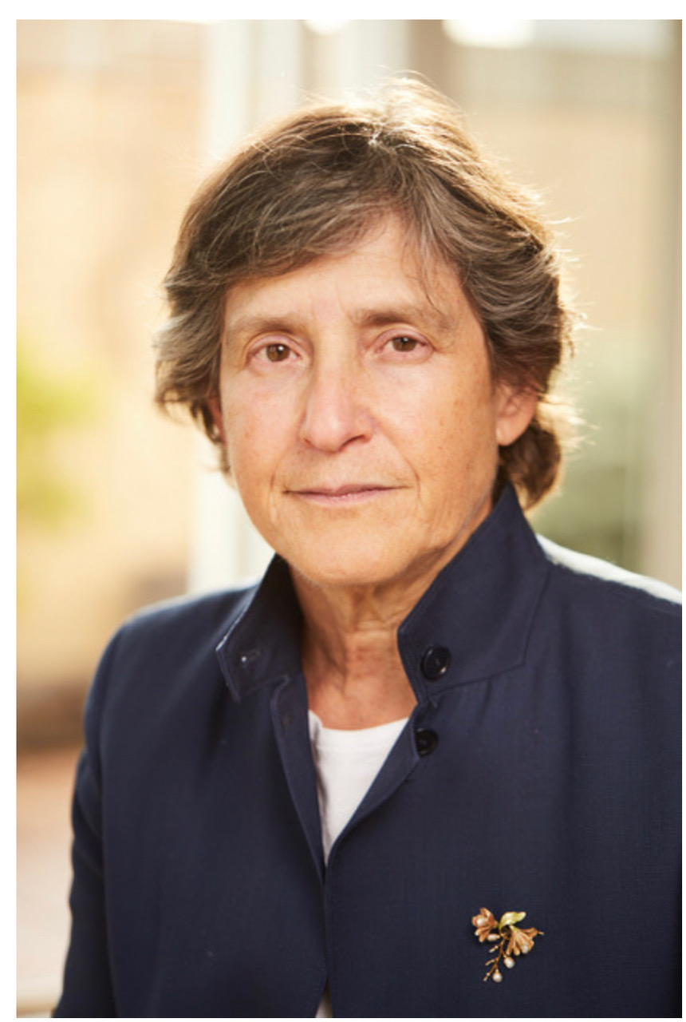

Elizabeth Glazer is the founder of Vital City. Most recently, she served as the director of the New York City Mayor’s Office of Criminal Justice where she led the strategy to produce a dramatic reduction in the jail population and to create community-led safety strategies. She previously oversaw the criminal justice agencies in New York State as the governor’s deputy secretary for public safety. She is a former federal prosecutor and clerked for then-U.S. Circuit Court Judge Ruth Bader Ginsburg.

Theresa Abreu

Teresa Abreu is a licensed attorney with diverse experience in juvenile and criminal justice including serving as a juvenile justice consultant, a federally court appointed monitor, and subject matter expert for various jurisdictions. She also served as in-house counsel for a union representing police officers and correctional officers. Teresa’s experience also includes serving as defense counsel for various agencies while employed at the Cook County State’s Attorney’s Office. As the Executive Director and Chief Legal Counsel of the Cook County Juvenile Temporary Detention Center (“JTDC”), she led operations and ensured compliance with federal, state, and local laws and standards; worked with accrediting agencies; developed collaborative relationships with other agencies; managed a 600+ workforce with complex legal and labor issues; and obtained substantial compliance with federal court orders in Doe v. Cook County et al., 99 C 3945.

Illinois State Senator John Curran
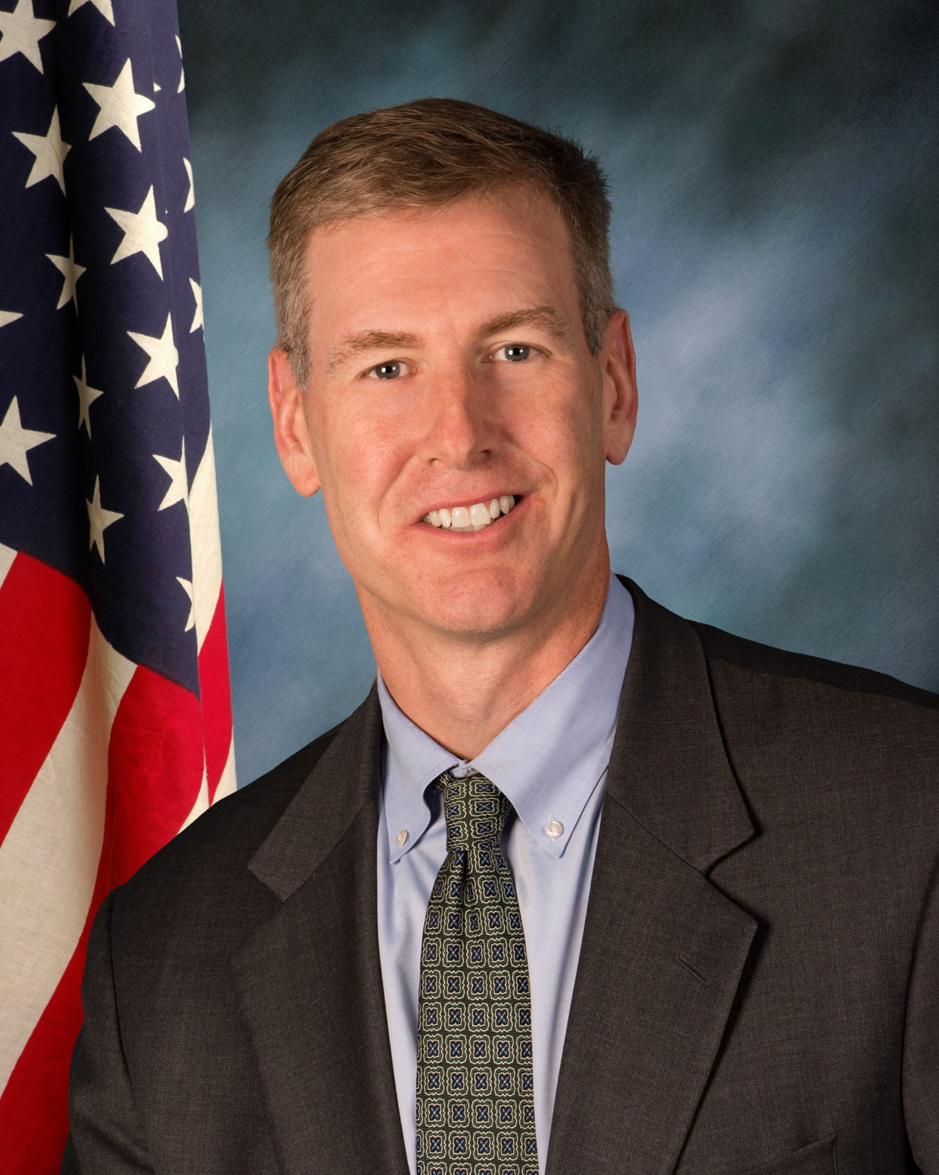

Senator John F. Curran was sworn in to represent the 41st District in the Illinois Senate in July of 2017. Prior to joining the General Assembly, Curran served as the Vice-Chairman of the DuPage County Board, and was a board member from 2008 to 2017. While sitting on the County Board, he led the implementation of cost-saving personnel policy reforms that are projected to save DuPage County $28 million over the next 20 years. Following 19 years working as an Assistant State’s Attorney in the Cook County State’s Attorney’s Office, Curran now works as an attorney at a private law firm in Oak Brook. He received his Juris Doctor Degree from Northern Illinois University College of Law and Bachelor of Science Degree from the University of Illinois at Urbana-Champaign. Curran is the Minority Spokesman for the Senate Assignments and the Senate Ethics Committees; he serves as a member of the Health, Healthcare Access & Affordability, Higher Education, Licensed Activities and Insurance Committees in addition to sitting on the Board of Directors for the Downers Grove Economic Development Corporation. Curran, his wife, Sue, their four daughters and a niece live in Downers Grove.
Thomas Geragthy
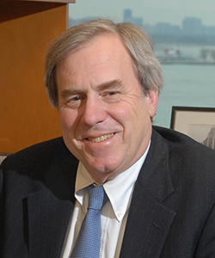
Thomas Geraghty is the Class of 1967 James B. Haddad Professor of Law, and formerly the Associate Dean for Clinical Legal Education and Director of the Bluhm Legal Clinic at the Northwestern University School of Law. In addition to teaching, fund-raising, and administrative responsibilities at the Bluhm Legal Clinic, Thomas Geraghty specializes in criminal and juvenile defense, death penalty appeals, child-centered projects dealing with the representation of children and juvenile court reform.
During the last 10 years, Professor Geraghty has also worked in Tanzania, Uganda, and Malawi on research projects with law students involving juvenile justice, the legal problems of street children, the status of children orphaned by HIV/AIDS, women in the legal profession, and freedom of the press. In 1996, He helped to design a clinical curriculum for the Addis Ababa University School of Law and recently completed an assessment of Legal Education in Ethiopia for ABA/ROLI. He is an advisory board member of the Governance and Justice Group (GJG) which recently completed the Justice Audit Bangladesh, a comprehensive analysis of the country’s criminal justice system. Professor Geraghty is a member of the Board of Trustees of the National Institute for Trial Advocacy.

Ben Wolf
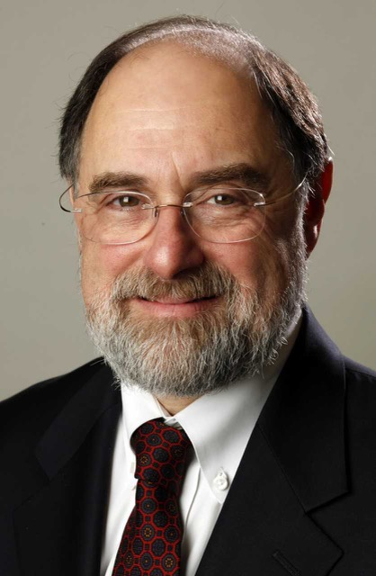

Benjamin S. Wolf was the Legal Director of the ACLU of Illinois from 2015 to April of 2020, working to protect women’s and reproductive rights, the rights of people in the LGBTQ community, freedom of speech and religion, victims of unlawful discrimination, victims of police mistreatment, and children and adults in government custody. Prior to that position, Wolf was the Director of ACLU of Illinois Institutional Reform Project since 1984, which provides legal representation to Illinois residents of prisons, jails, mental health centers, developmental centers, and government-funded nursing homes and children who are wards of the state. Under his direction, the Project has challenged the systemic abuse and neglect of the most helpless of our citizens in the courts.

Wolf received his undergraduate degree from Washington University in St. Louis. He graduated cum laude from Boston College Law School in 1979 and was an editor of the Boston College Law Review. Wolf served as a law clerk for U.S. District Judge James B. Moran in the Northern District of Illinois from 1979 through 1980, and was an associate at Jenner & Block in Chicago from 1980 to 1984.

Panel Two:

Moderator:

Errol Lewis

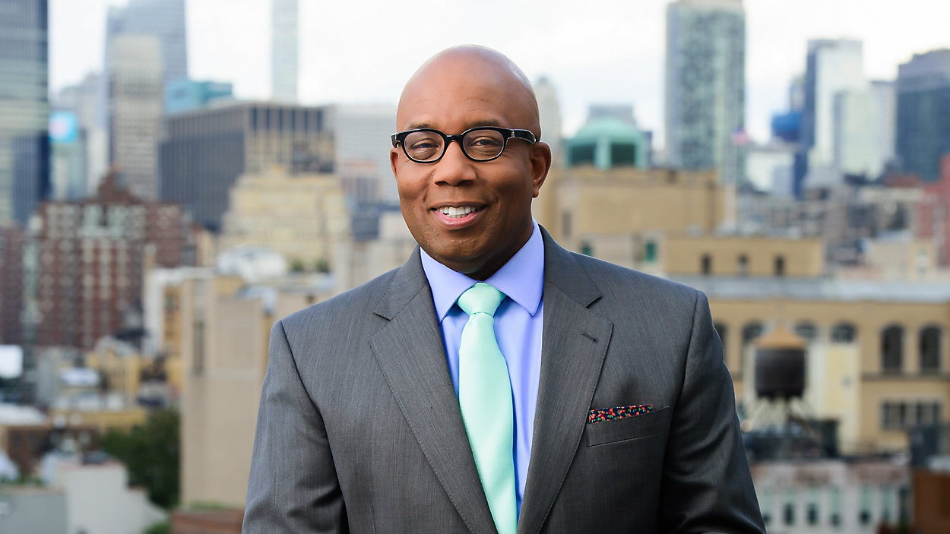
Errol Louis is the Political Anchor of Spectrum News NY1, where he hosts "Inside City Hall," a nightly primetime show about New York City politics where he interviews top political and cultural leaders. Louis has moderated more than two dozen debates between candidates for mayor, public advocate, city and state comptroller, state Attorney General and U.S. Senate. He was recently ranked #40 on the list of the 100 most powerful people in New York City politics. He is an adjunct professor of Urban Reporting at the CUNY Graduate School of Journalism as well as co-editor of Deadline Artists.
Louis was a Daily News opinion journalist from 2004 to 2010. He also hosted a weekday talk show on AM1600 WWRL, where he was twice named one of the "Heavy 100" top talk show hosts in America by Talkers Magazine. In 2010, he was named the city’s Best Columnist & Radio Show Host by the Village Voice.
A graduate of New Rochelle High School, Louis attended Harvard College, where he graduated with a B.A. in Government. He earned an M.A. in Political Science from Yale University and a J.D. from Brooklyn Law School.

Gladys Carrión

Gladys Carrión has been recognized as a national leader in her efforts to reform Juvenile Justice in New York State and a fearless advocate for children and families involved in the child welfare system. She currently is a Senior Fellow at the Columbia University Justice Lab and co-chairs the Youth Correctional Leaders for Justice where she advocates for the abolition of youth prisons and systems reform. Gladys was appointed Commissioner of the New York City Administration for Children's Services (ACS) in January 2014 and served until March 2020 where she was charged with providing child welfare, early childhood care and juvenile justice services to vulnerable children and families. She also implemented Close to Home, the City's juvenile justice program and right sizing the system.

Prior to her appointment to ACS, Gladys was Commissioner of the Office of Children and Family Services (OCFS). She began her legal career as an attorney with the Bronx Legal Services Corporation and became the Managing Attorney for the South Bronx Office. As an attorney, Gladys advocated for Bronx residents on a wide range of issues including housing, child welfare, education and family law. Born and raised in the Bronx, Gladys is a graduate of Fordham University and New York University School of Law.

Zachary Carter
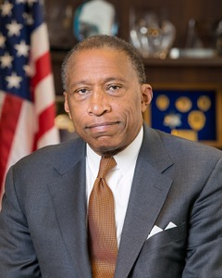

Zachary W. Carter served as the 78th Corporation Counsel of the City of New York from January 2014 through August 2019. As the chief legal officer of the City, he led the Law Department, which employs over 1,000 lawyers assigned across sixteen operating divisions to serve the multi-varied legal needs of the City. Mr. Carter advised the Mayor and City commissioners on all legal issues affecting City policies and operations. Prior to his appointment as Corporation Counsel, Mr. Carter was a partner in the firm of Dorsey & Whitney LLP. He served as the U.S. Attorney for the Eastern District of New York from 1993 to 1998, appointed by President Bill Clinton.

Mr. Carter has served on the bench, both as a judge of the Criminal Court of the City of New York and as a United States Magistrate judge for the Eastern District of New York. He began his legal career as an Assistant United States Attorney for the Eastern District of New York, ultimately serving as a deputy chief of the Criminal Division. Mr. Carter is a graduate of Cornell University and the New York University School of Law.

Michael Jacobson
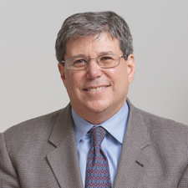

Michael Jacobson is ISLG's founding Executive Director as well as a sociology professor at the CUNY Graduate Center (GC). Prior to joining CUNY in May 2013 to help create ISLG, Michael was president of the Vera Institute of Justice, serving from 2005 to 2013. He is the author of Downsizing Prisons: How to Reduce Crime and End Mass Incarceration (New York University Press 2005). Holding a Ph.D. in sociology, he has had an ongoing academic career coupled with more than 20 years of government service. From 1998 to 2005 he was a professor at John Jay College of Criminal Justice and the GC. He was New York City correction commissioner from 1995 to 1998, New York City probation commissioner from 1992 to 1996, and worked in the New York City Office of Management and Budget from 1984 to 1992 where he was a deputy budget director. In 2010 to 2012, Michael served as the chair of Altus, a global alliance working across continents and from a multicultural perspective to improve public safety and justice.

Stanley Richards
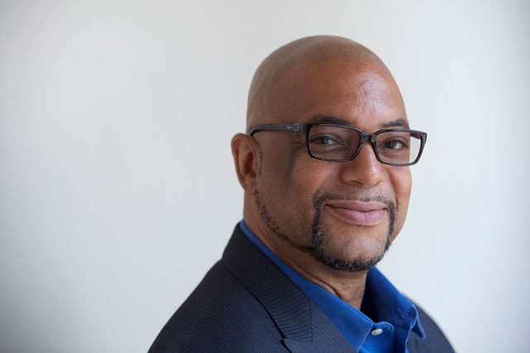

Stanley Richards is the Deputy Chief Executive Officer of The Fortune Society, a service and advocacy non-profit organization in New York City, founded by David Rothenberg in 1967. The Fortune Society’s mission is to support successful reentry from prison and promote alternatives to incarceration. Stanley is a formerly incarcerated man of color with decades of experience in the criminal justice field. In 2014, Stanley was recognized by the Obama administration as a Champion of Change for his commitment to helping individuals impacted by the justice system, and became the first formerly incarcerated person to be appointed to the NYC Board of Correction.

As Vice Chair of the Board of Correction, in June 2020, Stanley was appointed to lead the Working Group to End Punitive Segregation. In July 2021, he was appointed to become the First Deputy Commissioner of Programs and Operations at the New York City Department of Correction (NYCDOC). He was the first formerly incarcerated person to serve this second highest position within the NYCDOC, the second largest jail system in the country. Stanley is a graduate of Medaille College, Columbia University’s Graduate School of Business: Institute for Not-For-Profit Management Executive Level Program, and the Robert Wood Johnson Fellowship Program.

